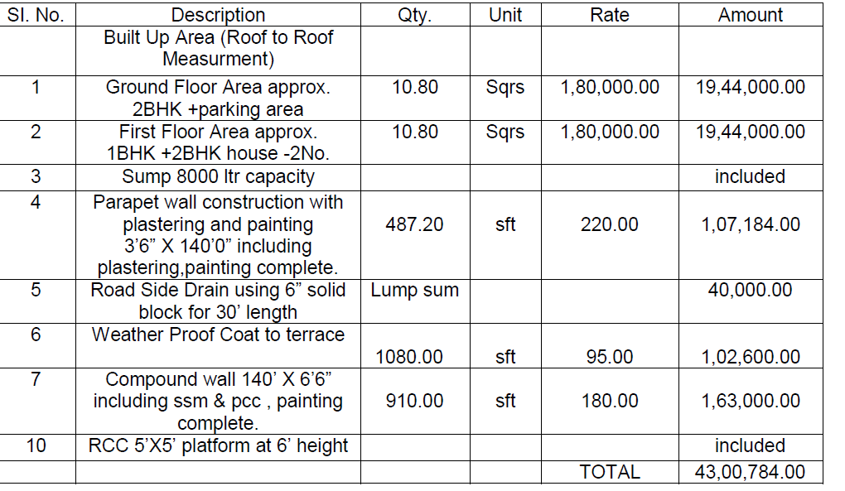
Note:
The above said work will be completed in 8 to 10 months.
Architecture features in elevation will be extra.
Interior Works like Kitchen Cabin,Wardrobes,TV unit,Glass Railings,POP,etc is not included in the above quote.

Structural Details:
Floor height is 10’ including slab thickenss
Structure (column,beam & slab) will be as per structural details designed for G+3 Floors
Column will be excavated 5’ to 6’ depth.
Column And Beam size will be used as per design floors.
Plinth level will be considered 1’0” above the existing road level
10mm rods will be used for footing, for column and beam 16mm & 12mm dia rods,10mm and 8mm for slabs,lintels & chajjas. will be used as per design
6” solid block wall for outer walls,internal 4” solid block wall, parapet compound wall will be constructed using 4” Solid Block
Cement: 53 Grade for RCC work & PCC Grade for masonry and plastering, Birla A1/Priya/Zuari/ACC or equivalent ISI make will be used
Ready Mix Concrete M20 Grade concrete will be used if required.
Reinforcement steel: Sunvik/Kamadhenu /Turbo Fe 500
MS Railings is Included Basic design outside
Over head tank: 5’ X 5’RCC platform , PVC tank 1000 liters .
Parapet : 3’6" Height with 4” thick Solid block wall.
Robo Sand will be used for Concrete,SSM,Flooring & Wall Constructions
River Sand or Plastering M Sand for outside plastering depending on the availability.
Plastering M Sand for inside plastering.

2. Openings Details:
6" x 3" in section for main door & 5”X3” in section for puja door African/Sudan Teak door for FF house all with antique hinges, Tower bolt, door stopper and 1 no. of door lock of approved make for main door.
Main Door Size 3’6” X 7’0” main door & puja door 3’0”X7’0” (1.5” thick teak shutter door for main and puja door will be used )
5" x 3" in section for Honne door for all GF main doors with antique hinges,Tower bolt, door stopper and 1 no. of door lock of approved make.
Door Size 3’6” X 7’0”(1.5” thick Honne shutter door for main and puja door will be used)
5" x 3" in section of Beavu wood frame for all houses room doors with flush shutters ss coated hinges, Tower bolt and door stopper. Door Size 3’0” X 7’0” (Flush Doors basic 190.00 Rs per sft)
5" x 3" in section of Beavu wood frame for all window frames with Honne shutters with ss coated hinges, Tower bolt and door stopper.
Kitchen window size 3’0” X 3’0”,Room window size 5’0”X4’0” with safety rods & ventilator size 2’6”X 1’6”
Aluminum louvers for bath room ventilators
Fiber Frame & Fiber shutters for all bath rooms will be provided.

3. Flooring and Wall Tiles :
Approved design & color 18mm thick granite for all house basic price Rs. 100.00/- per sft
Approved 25mm Granite Kitchen top Basic 150.00/- Rs & 4’0” Height ceramic tiles basic price Rs. 45.00/- for all houses
Approved design & color 18mm thick granite for staircase basic price Rs. 75.00/- per sft
Car parking/Balcony/passage anti skid ceramic tiles basic price 40.00/-
Ceramic tiles basic price 40.00/- will be used upto 7’ height in bathrooms & Concrete Flooring will be provided for Setback.

4. Painting:
External: Two coats of ACE of approved colour over a primer coat - Asian Paint
Internal: Two coats of Tractor emulsion of approved colour over two coats of wall Puttty (Asian Paint)

5. Electrical:

ISI make switches,PVC coundut pipes,Finolex/Anchor wires,Anchor/Havells switches & 1 fan point,2 tube light point, 2 socket in each area will be provided and any kind of office charges will be paid by the owner.
UPS connection provision will be provided in all houses.
5Amp socket for lighting purpose will be provided & 15Amp socket will be provided for heavy power supply area like Kitchen & bath room (washing machine,Fridge,geser & mixy)

6. Plumbing and Sanitary:
Supreme make PVC items will be used for sanitary work
ashirvad/astral make CPVC items will be used for plumbing work Sanitary & plumbing fittings like commode, taps, washbasin,etc)
This Quotation will not Include the Below Works.
1. Granite Cladding/wall tiles to parking wall, Passage wall,Balcony’s,near main doors,etc will be extra.
2. Foundation work if the earth is rock type SSM/RCC retaining wall if necessary will be extra .
3. Glass work, colour glass for Railings will be extra.
4. Increase in materials cost of more than 5% the difference will be added in the bill.

5. Amount Paid by Cheque/RTGS/NEFT etc 18.0 % GST will be Additional.

6. Job do not includes Electrical office charges,Safety Grill jobs etc
7. Borewell work,Temporary water supply and Electrical charges at the time of constructions.
8. Electrical meter work & pole work, Texture Paints & single wall dark colour,chain link steps,solar,lift Electrical work,Elevation,other interior work will be extra as per actuals,etc
9. The job includes roof to roof measurement system & Billing will be as per actual (APA)

